Name: Arnav Deo | SAP ID: 60004230285
Date of Performance: 14/08/2024 | Date of Submission: 21/08/2024
Experiment No: 2 Aim: Write a program to implement Framing: Techniques: Character count, Byte stuffing, Bit stuffing
Program:
import java.util.Scanner;
public class Charcount{
public static void main(String []args){
Scanner sc= new Scanner(System.in);
System.out.println("Enter first string :");
String str1=sc.nextLine();
System.out.println("Enter second string :");
String str2=sc.nextLine();
int len1=str1.length()+1;
int len2=str2.length()+1;
String result= len1+str1+len2+str2;
System.out.println("Output : "+result);
sc.close();
}
}

import java.util.Scanner;

public class ByteStuffing {
public static void main(String[] args) {
Scanner sc = new Scanner(System.in);
System.out.println("Enter string : ");
String str = sc.nextLine();
System.out.println("Enter start charachter :");
char start = sc.next().charAt(0);
System.out.println("Enter end charachter :");
char end = sc.next().charAt(0);
System.out.println("Enter escape charachter :");
char esc = sc.next().charAt(0);
StringBuilder result = new StringBuilder();
for (char c : str.toCharArray()) {
if (c == start || c == end) {
result.append(esc);
}
result.append(c);
}
System.out.println("Output :" + start + result.toString() + end);
sc.close();
}
}

Screenshots:

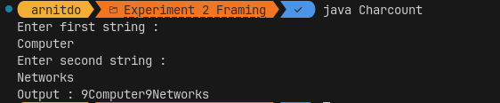
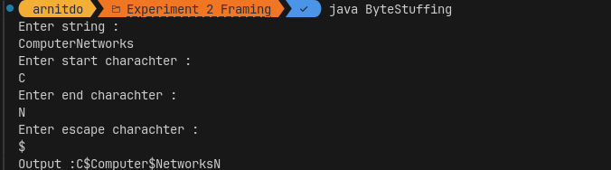
Conclusion:
Thus, we have studied and implemented the various framing techniques.

